OXFORD CITY PLANNING COMMITTEE | 10th August 2021

Application number: | 21/01495/FUL
Decision due by | 29th July 2021
Extension of time | 17th August 2021
Proposal | Formation of 1no rear dormer in association with a loft conversion and insertion of 3no rooflights to front elevation.
Site address | 65 Owens Way, Oxford, OX4 2GG
Ward | Temple Cowley Ward
Case officer | Tim Hunter

Agent: |  | Applicant: | Paul and Rachel Jeffrey

Reason at Committee | The applicant is an employee of Oxford City Council.

- RECOMMENDATION
  - Oxford City Planning Committee is recommended to:
    - approve the application for the reasons given in the report and subject to the required planning conditions set out in section 12 of this report and grant planning permission.
    - agree to delegate authority to the Head of Planning Services to:
finalise the recommended conditions as set out in this report including such refinements, amendments, additions and/or deletions as the Head of Planning Services considers reasonably necessary.

- EXECUTIVE SUMMARY
  - This report considers a proposal to erect a rear roof dormer and provide 3 roof-lights to the front roof-slope in association with a loft conversion. Partly because of similar development in the local area the proposal is not considered to be unacceptably harmful to visual or residential amenity. For those reasons the proposals are considered to comply with the relevant planning policies set out in the report and the NPPF.
- LEGAL AGREEMENT
  - This application is not subject to a legal agreement.
- COMMUNITY INFRASTRUCTURE LEVY (CIL)
  - The proposal is not liable for CIL.
- SITE AND SURROUNDINGS
  - The site is located in the Temple Cowley area of Oxford to the south-east of the city centre. The application site is a semi-detached house. The area is characterised by a mix of houses and flats, with three storey blocks of flats immediately to the North, North-west and North-east of the application site.
  - See site location plan below:
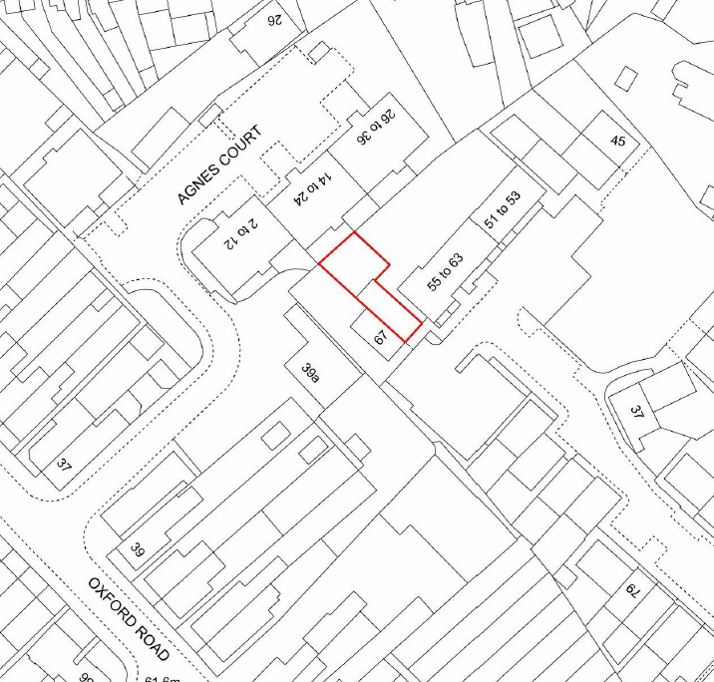
© Crown Copyright and database right 2019.
Ordnance Survey 100019348

- PROPOSAL
  - Permission is now sought for a rear roof dormer extension and 3 roof-lights to the front roof slope, in association with a loft conversion.
  - The dormer would be 2.1m high, with a width of 2.6m and would sit within a rear roof slope of 3.75m in height and 4.8m in width. As such, the dormer would preserve much of the existing roof slope and would appear as a small dormer within the roof, rather than as a flat roofed second floor.
  - It should be noted that planning permission would not normally be required for rear dormers in most cases but as a result of permitted development rights being removed for the property (04/02163/RES) planning permission is required.
- RELEVANT PLANNING HISTORY
  - The table below sets out the relevant planning history for the application site:
No relevant planning application history

- RELEVANT PLANNING POLICY
  - The following policies are relevant to the application:
Topic | National Planning Policy Framework (NPPF) | Oxford Local Plan 2036
Design | 117, 122, 124, 127, 128, 130, | DH1 – High quality design and placemaking
Environmental | 167, 183-185 | H14 – Privacy, daylight and sunlight
Misc | 11 | S1 – Presumption in favour of sustainable development

- CONSULTATION RESPONSES
  - Site notices were displayed around the application site on 17th June 2021.
Statutory and non-statutory consultees
Oxfordshire County Council (Highways)
  - No comments received.
Natural England
  - No comments received.
Public representations
  - No third party comments received.
- PLANNING MATERIAL CONSIDERATIONS

  - Officers consider the determining issues to be:

- Visual amenity
- Neighbouring Amenity

- Design and Impact on Character of Surrounding Area

  - The proposed dormer would be visible from Agnes Court to the rear. However in terms of scale, bulk and mass, the proposed development either reflects or is smaller than other similar development in the nearby local area particularly those at number 35 and 37 Oxford Road, both of which are also visible from Agnes Court.
  - The proposed dormer is also very similar (if not identical) to a dormer approved at 81 Owens Way under application 16/02794/FUL.
  - Because of its relatively small size in relation to the existing roof slope, the main rear roof slope would appear to be retained, with the dormer sitting within it, rather than replacing it. This accords with the general aims of Oxford City Council’s Planning Design Guide 5 – Rear Dormers.
  - Officers also note that most of the immediately surrounding properties are three storey blocks of flats with varying features such as two storey bay windows, small gable features etc as well as other dormer windows existing on other properties in the surrounding area, all visible from Agnes Court. The new dormer window and roof lights, serving accommodation at second floor level would therefore reflect the prevailing nature of development in the immediate local area, which is of three storey buildings or two storey buildings some of which have dormer windows as described. Therefore while the proposals will be visible from Agnes Court, in this context the proposals would be in-keeping, not unduly prominent or visually intrusive. As such the proposals would not harm visual amenity.
  - The proposed dormer would be clad in matching tiles to the main roof slope and is acceptable in design terms.
  - Subject to a condition to control the appearance of materials used in the build, the proposal is not considered to be unacceptably out of character with the existing dwelling or local area for the reasons given and would not result in unacceptable visual harm in compliance with Policy DH1 of the OLP 2036
- Impact on Neighbouring Amenity

  - Because of its position on the roof, the proposed dormer would not result in overshadowing or loss of daylight to the habitable rooms of the properties either side of the site. With regard to the block of flats at Agnes Court that are immediately behind the site, the 25 degree line would pass above the proposed dormer, indicating no unacceptable loss of light to the habitable rooms of that building.
  - The proposed development would not be unduly overbearing, enclosing or oppressive.
  - In terms of overlooking, there would be the opportunity for mutual overlooking of the flats at Agnes Court and surrounding gardens, but this would be little different to the existing overlooking from first floor windows and highly similar to the potential for overlooking from the second floor windows of the immediately adjacent 57 – 63 Owens Way and Agnes Court. Indeed, overlooking of surrounding gardens would be less from the dormer than from the windows at 57 – 63, because of its set back from the main rear wall.
  - The proposed roof lights would face the street, where overlooking across public areas is to be expected. In any event, roof lights do not tend to be experienced as so overlooking as vertical panes of glass and overall, the impact of the roof lights on surrounding occupiers would be acceptable.
  - On the above basis, the impact on adjacent occupiers would be limited and acceptable. The proposal therefore complies with Policy H14 of the OLP 2036.
- CONCLUSION
  - Having regards to the matters discussed in the report, officers would make members aware that the starting point for the determination of this application is in accordance with Section 38 (6) of the Planning and Compulsory Purchase Act 2004 which makes it clear that proposals should be assessed in accordance with the development plan unless material considerations indicate otherwise.
  - The NPPF recognises the need to take decisions in accordance with Section 38 (6) but also makes clear that it is a material consideration in the determination of any planning application (paragraph 2). The main aim of the NPPF is to deliver Sustainable Development, with paragraph 11(c) providing that decision-taking means approving development proposals that accord with an up-to-date development plan without delay. The NPPF also goes on to state that development plan policies should be given due weight depending on their consistency with the aims and objectives of the Framework. The relevant development plan policies are considered to be consistent with the NPPF.
  - Therefore in conclusion it would be necessary to consider the degree to which the proposal complies with the policies of the development plan as a whole and whether there are any material considerations, such as the NPPF, which are inconsistent with the result of the application of the development plan as a whole.

  - Officers would advise members that having considered the application carefully, the proposal is considered to be acceptable in terms of the aims and objectives of the National Planning Policy Framework, and relevant policies of the Oxford Local Plan 2036, when considered as a whole, and that there are no material considerations that would outweigh these policies. On the basis of the above, Officers recommend that the Oxford City Planning Committee grant planning permission for the proposed development for the reasons set out at the beginning of this report subject to the conditions set out below.
- CONDITIONS
1 The development to which this permission relates must be begun not later than the expiration of three years from the date of this permission.

Reason: In accordance with Section 91(1) of the Town and Country Planning Act 1990 as amended by the Planning Compulsory Purchase Act 2004.

2 The development permitted shall be constructed in complete accordance with the specifications in the application and approved plans listed below, unless otherwise agreed in writing by the Local Planning Authority.

Reason: To avoid doubt and to ensure an acceptable development as indicated on the submitted drawings in accordance with policy DH1 of the Oxford Local Plan 2036.

3 Unless otherwise approved in writing by the Local Planning Authority, the materials to be used shall be as specified in the approved plans and supporting documents.

Reason: To ensure that the new development is in keeping with existing building(s) in accordance with policy DH1 of the Oxford Local Plan 2036.

INFORMATIVES :-

1 In accordance with guidance set out in the National Planning Policy Framework, the Council tries to work positively and proactively with applicants towards achieving sustainable development that accords with the Development Plan and national planning policy objectives. This includes the offer of pre-application advice and, where reasonable and appropriate, the opportunity to submit amended proposals as well as time for constructive discussions during the course of the determination of an application. However, development that is not sustainable and that fails to accord with the requirements of the Development Plan and/or relevant national policy guidance will normally be refused. The Council expects applicants and their agents to adopt a similarly proactive approach in pursuit of sustainable development.

- APPENDICES
- Appendix 1 – Site plan

- HUMAN RIGHTS ACT 1998
  - Officers have considered the implications of the Human Rights Act 1998 in reaching a recommendation to grant this application. They consider that the interference with the human rights of the applicant under Article 8/Article 1 of Protocol 1 is justifiable and proportionate for the protection of the rights and freedom of others or the control of his/her property in this way is in accordance with the general interest.
- SECTION 17 OF THE CRIME AND DISORDER ACT 1998
  - Officers have considered, with due regard, the likely effect of the proposal on the need to reduce crime and disorder as part of the determination of this application, in accordance with section 17 of the Crime and Disorder Act 1998. In reaching a recommendation to grant planning permission, officers consider that the proposal will not undermine crime prevention or the promotion of community.

Appendix 1 – Site Plan

